Japanese Cooking Class

Rice

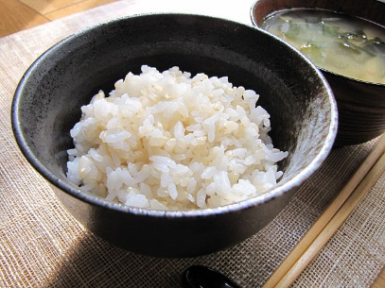

Ingredients

* White rice

Directions

1. Measure the rice with the rice cup. 1 cup = 150g
2. Pour water, throw it away without mixing it. (Rice absorbs water quickly. Rice has rice bran, so we get rid of rice bran by rinsing. We throw the first water away to prevent rice from absorbing the water with rice bran.)
3. Wash, sharpen the rice by pressing. (wash it gently)
4. Add water, stir it. Throw away the white water.
5. Repeat 2 & 3 several times. (3-4 times)
6. Put water according to the measure of the pot. If you put 2 cups, put water up to level 2.
7. Set it on rice cooker.

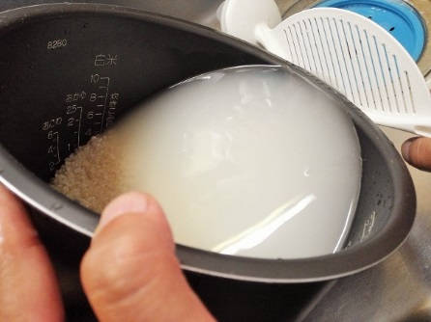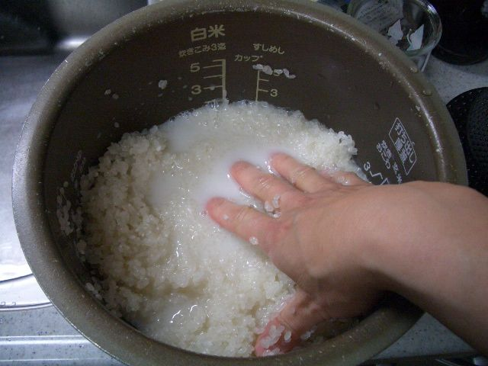

Soup stock **(**Dashi**)**

The very basic of Japanese dishes. **Dashi** has **Umami** flavor that makes dishes more savory.

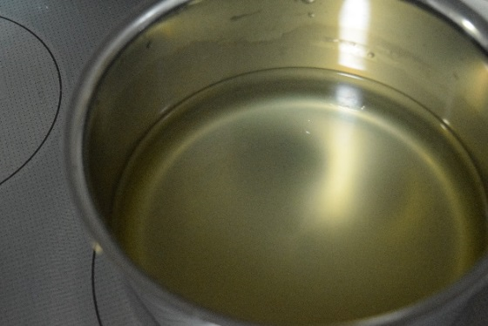

Ingredients

* Kombu kelp 10g
* Water 1000ml
* Bonito flakes 20g

Directions

1. Put Kombu kelp into 1000ml water and boil.
2. Before it boils, take out the Kombu kelp(so that we can get only umami from the sea weed, not its bitterness). Then, put 20g of bonito flakes
3. When the water is boiled enough, turn off the heat and wait until the bonito flakes sink at the bottom.
4. Pass the soup through a filter.

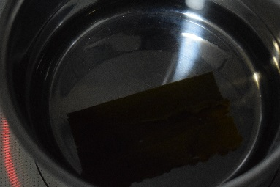 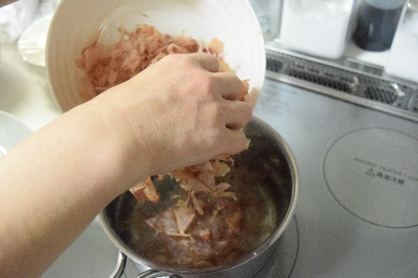

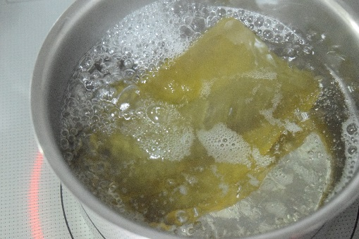 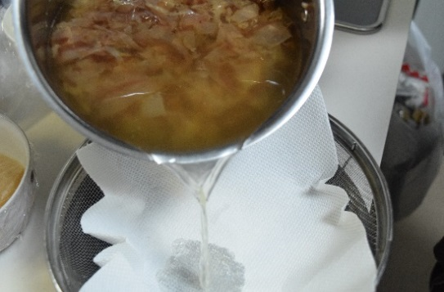

Miso soup (*Misoshiru*)

The most typical Japanese soup.

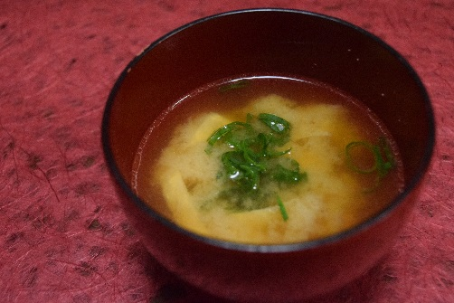

Ingredients (serves 4)

* Dashi 1000ml
* Miso 40g
* Tohu 50g
* Green onions* 5g
* Fried tofu* (Aburaage) 10g *Additional

Directions

1. Boil the 1000ml of Dashi and put 40g of Miso into the Dashi soup.
2. Slice tofu into small dices(1cm×1cm) and put them into the soup
3. Likewise, cut green onions into small pieces and put them into the soup.

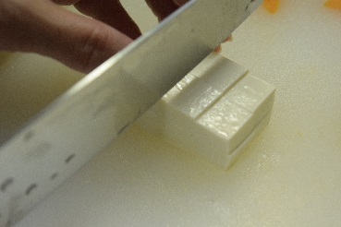 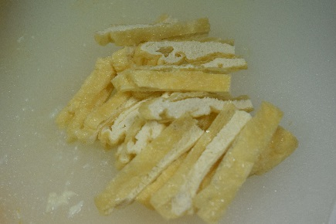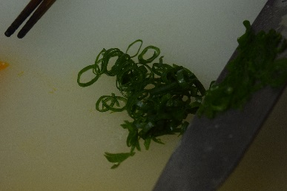

Simmered Mackerel (Saba no nimono)

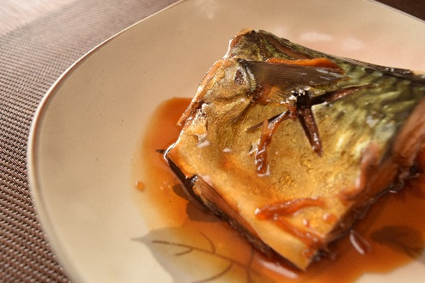

Ingredients (serves 2)

* Mackerel 2 fillets 200g-300g
* Ginger 1 pinch
* Water 100ml
* Cooking sake 50ml
* Mirin 50ml
* Sugar 1Tbsp
* Soy sauce 25ml

Directions

1. Put salt on mackerels, leave them for 20-30 minutes.
2. Wipe off the moisture
3. Add seasonings and ginger, boil it.
4. When it’s boiled, turn down to mid-low heat and put mackerels. Put aluminium foil lid.
5. Simmer them about 20 minutes. Sometimes scoop the sauce and pour it on 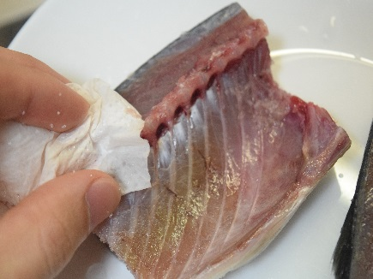 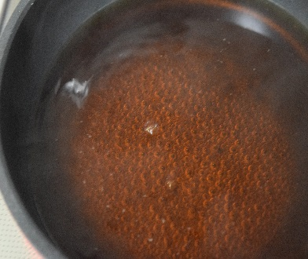 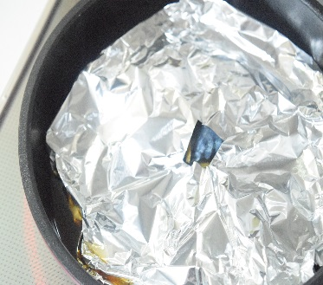

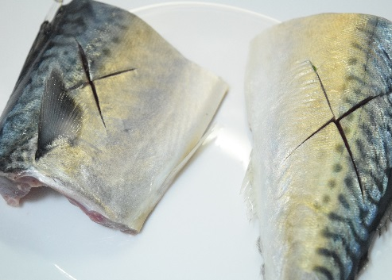 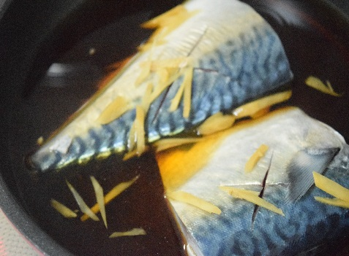

Egg roll (Dashimaki tamago)

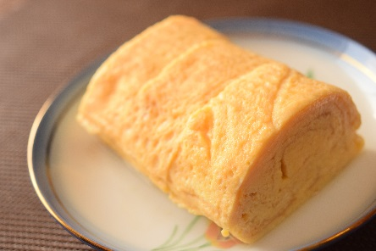

Ingredients (serves 2)

* Egg 3
* Dashi 100ml
* Salt 1/3 tsp
* Soy sauce 1/3 tsp

Directions

1. Mix all the ingredients in a bowl.
2. Put oil, pour only 1/4 of it on the pan.
3. When it starts getting hard, roll it over from top side to bottom.
4. When it’s rolled, move the rolled egg to the top.
5. Pour another 1/4 of the egg on the pan. Roll it again.
6. Repeat process 2-4.
7. Put egg roll on Makisu, leave it for a few minutes. Cut it into bite size.

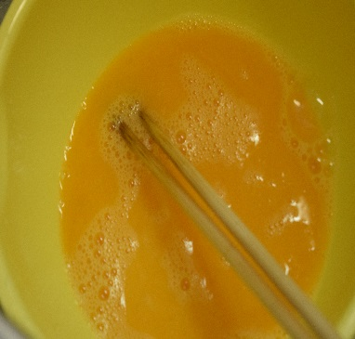 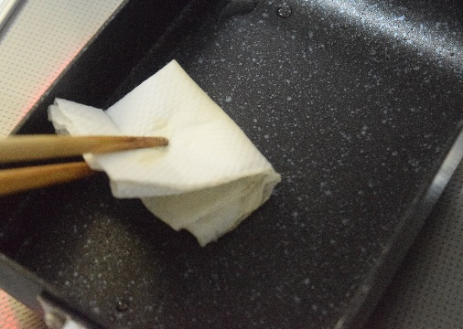 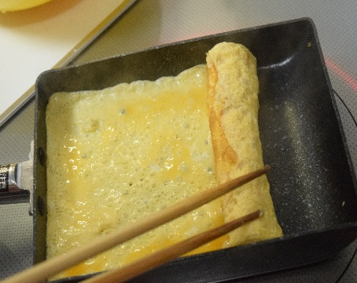

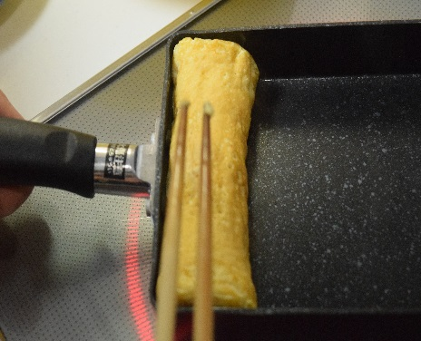 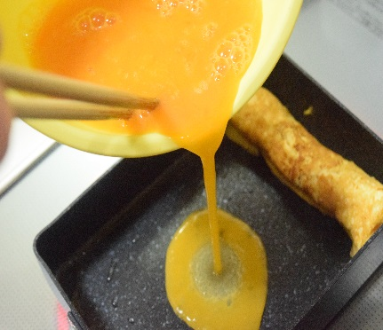 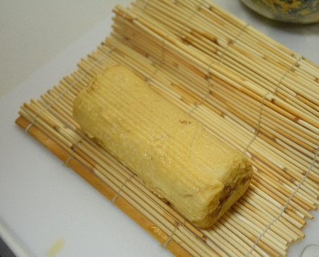

Spinach with sesame seed (horenso no gomaae)

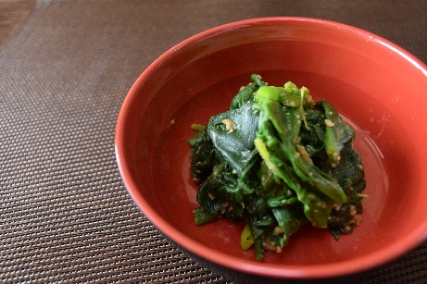

Ingredients (Serves 4)

* Spinach 200g
* Miso 1Tbsp
* Sugar 2tsp
* Ground sesame 2Tbsp
* Dashi 1Tbsp

Directions

1. Wash Spinach
2. Put salt into boiled water, boil spinach
3. After boiling, take it out and cool it down with cold water.
4. Cut the spinach
5. Mix spinach, miso, sugar, ground sesame, and dashi

